MATLAB programs for chapter 7

Program 1: A program to design a digital resonator with transfer function given by 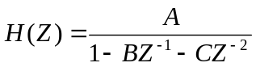with
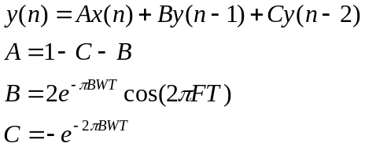

clear all;
T=1/8000;
F=1000;
BW=200;
B=2*exp(-pi*BW*T)*cos(2*pi*F*T);
C=-exp(-2*pi*BW*T);
A=1-C-B;
a=[A];
b=[1 -B -C];
[c,w]=freqz(a,b,256,8000);
plot(8000/256*w/pi,20*log10(abs(c)));
title('frequency response of the resonator');
xlabel('frequency in Hz');ylabel('gain in dB');
The frequency response of the resonator obtained as the output of MATLAB program is shown in Figure 7.5.
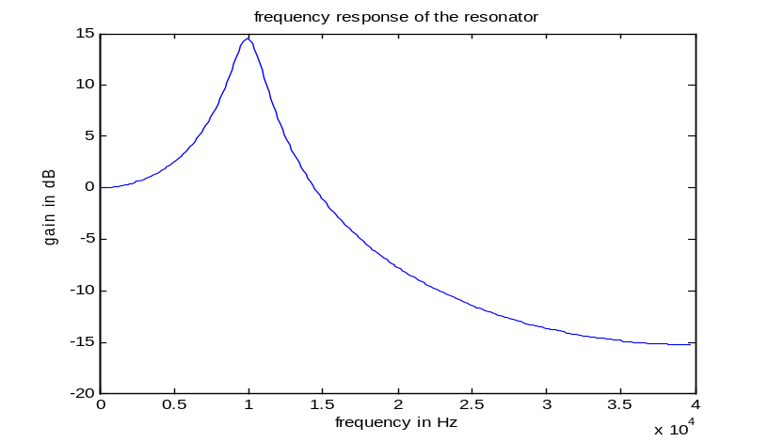
Figure 7.5 Frequency response plot of a resonator
Program 2: Let us find the frequency response of the block radiation characteristic by writing a MATLAB program given by
clear all;
T=1/8000;
a=[1 -1];
b=[1];
[c,w]=freqz(a,b,256,8000);
plot(8000/256*w/pi,20*log10(abs(c)));
title('frequency response of the radiation characteristic');
xlabel('frequency in Hz');ylabel('gain in dB');

The radiation at the lips is simulated as

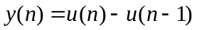 7.3
The Z domain transfer function can be written as
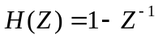 7.4
The frequency response of the radiation characteristic obtained as the output of MATLAB program is shown in Figure 7.7.
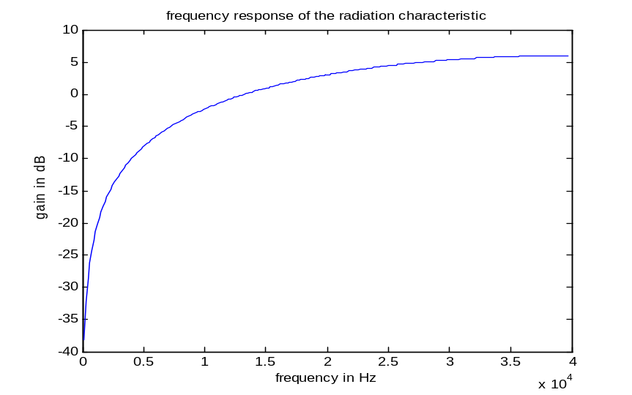
Figure 7.7 Frequency response of the block ‘radiation characteristic’

